DBMS

Lab Exercise: DDL and DML

1. Create the table .  
   Table: Employee

|  |  |
| --- | --- |
| ATTRIBUTE (FIELD) NAME | DATA DECLARATION |
| EMP_NUM | CHAR(3) |
| EMP_LNAME | VARCHAR(15) |
| EMP_FNAME | VARCHAR(15) |
| EMP_INITIAL | CHAR(1) |
| EMP_HIREDATE | DATE |
| JOB_CODE | CHAR(3) |

1. Having created the table structure in question 2, write the SQL code to enter the rows for the table shown

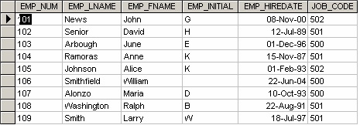

1. Use Figure to answer questions 4 to 10.
2. Write the SQL code to change the job code to 501 for the person whose personnel number is 107. After you have completed the task, examine the results, and then reset the job code to its original value.
3. Insert the data in Employee table, write the SQL code that lists all attributes for a job code of 502.
4. Write the SQL code to delete the row for the person named William Smithfield, who was hired on June 22, 2004, and whose job code classification is 500. (*Hint*: Use logical operators to include all the information given in this problem.)
5. Add the attributes EMP_PCT and PROJ_NUM to the Employee table. The EMP_PCT is the bonus percentage to be paid to each employee.
6. Using a single command, write the SQL code that will enter the project number (PROJ_NUM) = 18 for all employees whose job classification (JOB_CODE) is 500.
7. Using a single command, write the SQL code that will enter the project number (PROJ_NUM) = 25 for all employees whose job classification (JOB_CODE) is 502 or higher.
8. Write the SQL code that will change the PROJ_NUM to 14 for those employees who were hired before January 1, 1994, and whose job code is at least 501. (You may assume that the table will be restored to its original condition preceding this question.)